**The Basics of Financial Literacy: Getting and Building Credit**

Financial freedom takes time, patience, and just a little bit of know-how. Shondaland is here to help with our ongoing series on all-things money. This installment: understanding, and capitalizing on, credit.

Oct 17, 2019

AnchiyGetty Images

*Cardi B* [*said it best*](https://www.youtube.com/watch?v=zUOh09GoQgk)*: “All I really wanna see is the money.” Well, while seeing the money is great, what comes after you start to pad out your bank account is just as important as how you got the coins there in the first place. Thus, Shondaland, along with the help and expertise of MGO CPAs & Advisors accounting firm, is launching our financial education series, with the goal of helping anyone and everyone win at getting to your financial “happily ever after.” Designed to help you understand both what's influencing and driving our economy and also the fundamentals of basic fiscal planning, this information is designed to help you take control and effectively manage your finances now and as you plan for the future. You work hard, so, from budgeting to saving to investing, it’s all about making your money work hard for you, too.*

Chances are, you’ve heard or seen a TV commercials — or online ads — that are peddling ways to get your free credit score. And chances are, you’ve probably just gone right on tuning them out because, real talk, credit scores can be scary.

Plenty of people claim they have good credit, which, in the simplest terms, means they have a great credit score (more on that later) that enables them to effortlessly get a loan from a bank, buy a new car, or perhaps shop for the perfect place that they hope to make their home.

But, more often than not, the opposite is true. Bad financial luck or a few unfortunate fiscal choices can — and have — led many people to have a lower credit scores or overall bad credit, which can cause all kinds of problems with getting loans, lower interest rates, or renting a place to live. And some employers even look at a person’s credit score before hiring them. As you can see, your credit score can have a major impact on your life. So, before we talk about how to keep your credit in tip top shape, let’s break down what your credit score actually is.

**Credit Score 101:**

Credit scores began in 1989 by FICO, a data analytics company that developed [the FICO score](https://www.myfico.com/), a measure of consumer credit risk that has now become a mainstay in consumer lending. Basically, a credit score determines your creditworthiness when it comes to banks, financial institutions, or even cell phone companies, evaluating the potential risk — such as losses due to bad debt — that could come in lending money or services to consumers. For most, this manifests in lenders (like banks or credit card companies) using your credit score to determine if you qualify for a loan, at what interest rate, and what credit limits. Your credit score is determined by, more or less, five different criteria:

1. **Payment history** - The single most important factor affecting your credit score comes from when you make your payments, how much those payments are (the minimum amount or more) and if you make those payments on time. If payments are missed or less than the minimum, your score will decrease.
2. **Utilization** - The second most important criteria in determining a credit score is the balance-to-limit ratio on your credit cards. To figure out your utilization rate, add up all of your balances and all of your credit limits, then divide the total of your balances by the total of your limits. That percentage should be no more than 30%. Good utilization practice mandates that you pay your balances in full each month and, if possible, keep your rate below 10% to get the best credit score possible.
3. **Length of credit history** - This comes from looking at how long each of your accounts has been open.
4. **Credit mix** - the number of accounts, from mortgages to credit cards to loans, you have open.
5. **New credit** - Lenders like to know how much credit you've applied for in recent months. Typically, they'll look back over the last three to six months to check if you opened a new account, applied for credit inquiries, and if you are taking on more debt.

Some of the above five criteria hold more weight than others. Here's a breakdown of how lenders look at your credit:

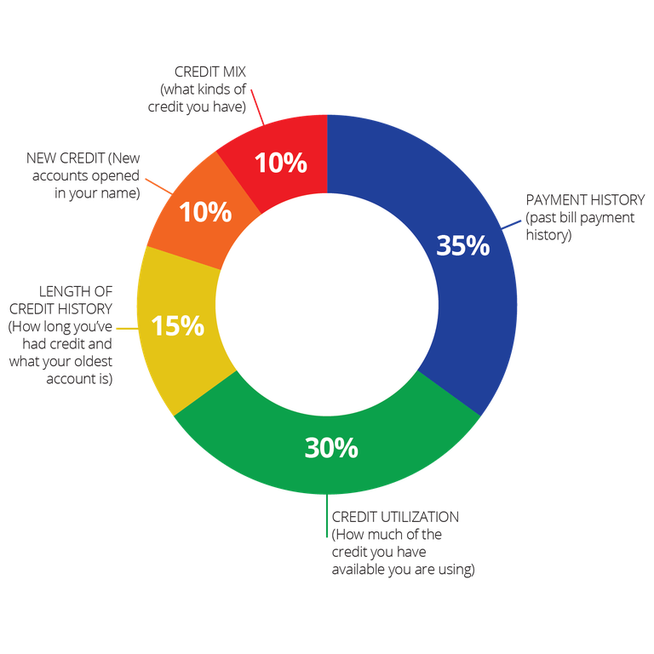

Now that we understand that, when does your credit start? Pretty much with the first loan or credit card you take out in your name. When it comes to making payments to these advances, if made on time and the debt is paid off, you’re starting out on the right foot for your credit history.

Student loans, personal (home and auto) loans, and some regularly occurring monthly bills like rent, phone bill, etc. are all further examples of things that can be added to or applied to helping you create a credit score. Ultimately, what we’re talking about here is using debt as a form of positive credit building. So let’s look at how it all breaks down.

**Credit at a glance**

The FICO score is the most commonly-used credit scoring model in the United States, and it ranges between 300 and 850. A FICO score of 703 is considered "good," and approximately 58 percent have a FICO score of 703 or greater.

As for age-group averages, credit scores in each age group increased by two points compared to 2018, and, [according to Experian](https://www.experian.com/blogs/ask-experian/what-is-the-average-credit-score-in-the-u-s/), Americans over 60 have the highest average credit score, at 749. For how other age demographics break down, Americans ages 50 to 59 hold the second-highest average of 706, while people between the ages of 40 and 49 have an average score of 684. Americans ages 30 to 39 score 673 on average and those between 20 and 29 average 662.

**How to get credit when you have none**

Now that we’ve established how important good credit is to making some big life steps, let’s address what, for some, can be a unique problem: having no credit of their own. Typically, young people are a part of someone else’s credit. But, when it comes time to be independent, they need to establish credit in their own name.

One common method that’s great for establishing a credit foundation is getting a secured card from a bank or institution. A secured card requires a cash security deposit which is refunded when you close or upgrade the card. Your credit limit on a secured card will almost always be equal to whatever you put down as a deposit.

Another option: you can also be added to someone else’s account with a line of credit that will then appear on your file. Parents, or even friends, if they’re willing — and in good credit standing themselves — can add you to an existing credit card as an authorized user. You don’t even have to use the card to have that new credit limit appear on your account and start reaping the credit-score benefits of their spending, so long as it’s responsible.

**Maintaining good credit**

For even the most conscious consumers, it can be easy for debt to spiral out of control and drag your credit score down with it. Late payments, whether they be loans or credit cards, can typically affect your credit history for seven years — or much longer if you really fall behind on payments. Think about your debt like a fly strip hanging from the ceiling: each time you miss or make a late payment, a fly gets stuck. What may seem small at first can quickly amass to become a large, buzzing, *very* angry horde of stuck flies if you don’t stay on top of your finances.

In order to maintain good credit, make a point to not overextend the credit you have been given. As much as it can feel like it, just because you have cards with limits in the thousands of dollars doesn’t mean you have thousands of free dollars. Spend what you can afford to pay back in a timely manner, don’t miss monthly payments — we recommend setting up an automatic payment that, if possible during any given month, you can increase — and don’t go over your personal limit or your monthly budget.

**Credit for emergencies**

Of course, there are exceptions to every rule, especially when life comes at you out of nowhere in the form of sudden medical expenses or other emergency events. In instances like these where you know you’re going to need to engage your credit to fix the issue, talk to your lender immediately and make sure that you can promptly pay back the debt without getting your credit score destroyed by late or missed payments.

Credit and debt are nothing to be afraid of but, like any other challenge in living your financial vision, they have to be maintained and monitored to be of benefit to you. Keep yourself operating within your monthly budget, you’ll be flaunting your good credit score in no time.